**DAILY ONLINE ACTIVITIES SUMMARY**

|  |  |  |  |  |  |  |  |  |
| --- | --- | --- | --- | --- | --- | --- | --- | --- |
| **Date:** | 02/06/2020 | | | | | **Name:** | D Richard Franklin | |
| **Sem & Sec** | Fourth SEM section A | | | | | **USN:** | 4AL18CS020 | |
| **Online Test Summary** | | | | | | | | |
| **Subject** | | N/A | | | | | | |
| **Max. Marks** | | N/A | | **Score** | | | N/A | |
| **Certification Course Summary** | | | | | | | | |
| **Course** | Python for machine learning | | | | | | | |
| **Certificate Provider** | | | greatlearning | | **Duration** | | | 3 Hour |
| **Coding Challenges** | | | | | | | | |
| **Problem Statement:** 1. Program to represent input mismatch exception  2. Perfect sum problem | | | | | | | | |
| **Status:** Completed | | | | | | | | |
| **Uploaded the report in Github** | | | | | YES | | | |
| **If yes Repository name** | | | | | <https://github.com/richard3658/lockdown-coding> | | | |
| **Uploaded the report in slack** | | | | | YES | | | |

**Online Test Details: N/A**

**Certification Course Details:**

**Name of the course**: Python for machine learning

**Certificate Provider**: greatlearning

This course has 5 sections and the total duration is 5 hours.

On 02/06/2020 I went through the section of the course that explained about how python can be used for machine learning, why machine learning and how is python better than other languages for machine learning.

**Snapshot:**

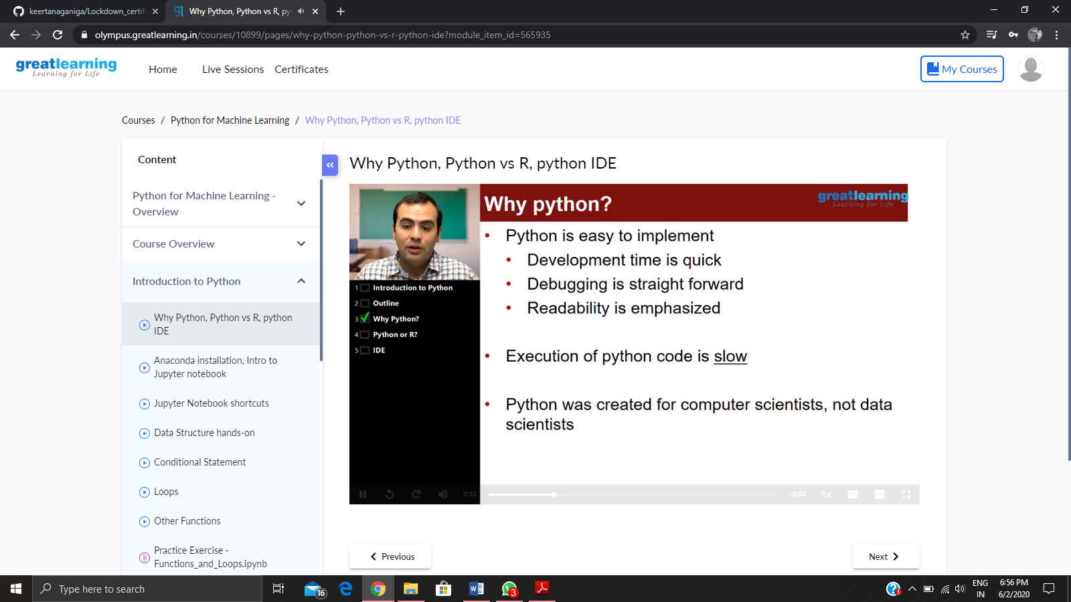

**Online Coding Details:**

Problem 1: (using JAVA) Write a program in java, an array of integer data to be initialized. During the initialization, if a user enters a value other than integer value, then it will throw InputMismatchException exception. On the occurrence of such an exception, your program should print “You entered bad data.” If there is no such exception it will print the total sum of the array.

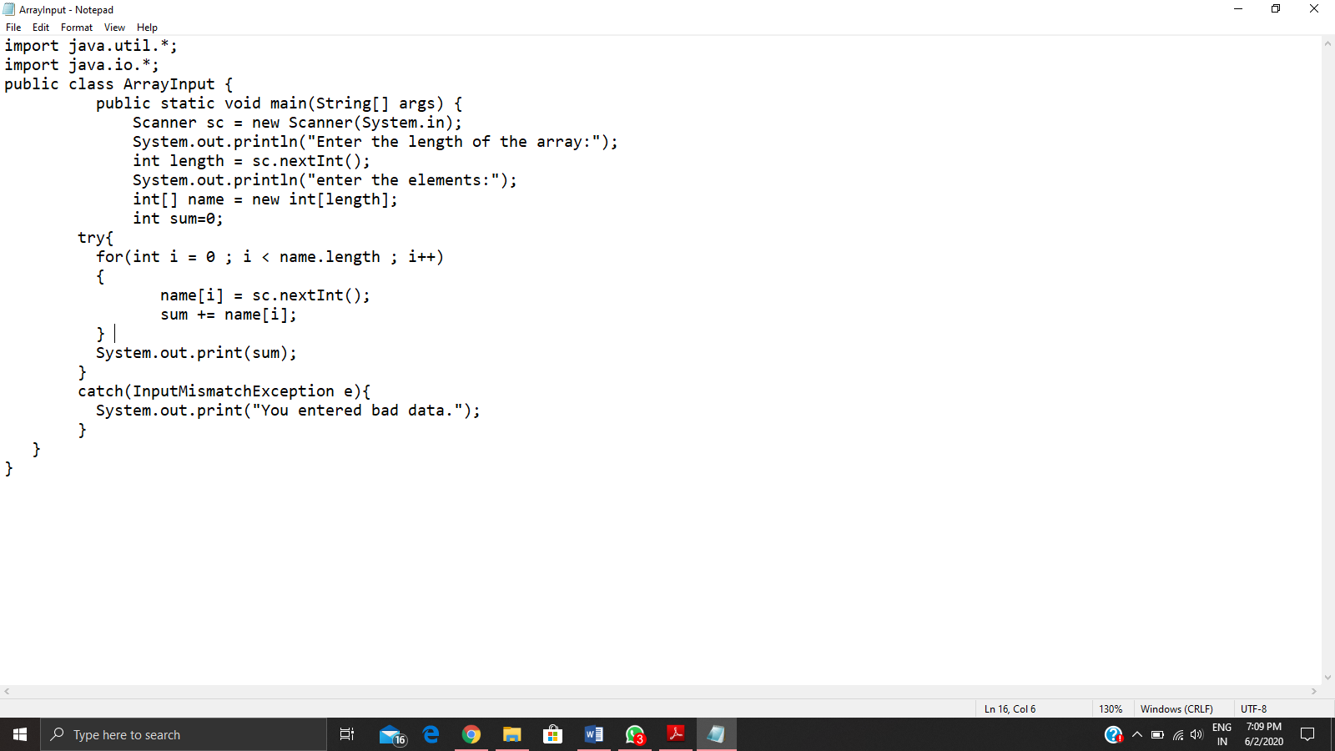

Problem 2: (using JAVA) Given an array arr[] of integers and an integer K, the task is to print all subsets of the given array with the sum equal to the given target K.

